Draft CPD Guidelines

January 2018

Introduction
This guidance supports osteopaths in meeting the General Osteopathic Council (GOsC) Continuing Professional Development (CPD) scheme requirements. The CPD scheme provides assurance of continuing fitness to practise for every osteopath on the statutory Register, by encouraging osteopaths to develop their practice as members of a community of learning.
Culture
‘Helping explore osteopathy within a supportive community’
The CPD scheme is designed to promote engagement, professional support, discussion and ‘learning communities’ within osteopathy, putting patients at the heart of osteopathy, and thereby ensuring high quality patient care and patient safety.
This approach requires osteopaths to participate fully and show interest in CPD activities, helping colleagues to feel valued and promoting discussion about practice. It relies on:
- a respectful environment where colleagues can share details of their practice openly
- the skills to give and receive constructive feedback
- demonstrating attitudes of curiosity and the ability to learn from every encounter with colleagues
- valuing the new knowledge and insights that colleagues and patients can bring.
We want to create a culture where osteopaths are empowered to:
- inspire and influence others through the shared aim of creating benefits for patients, practitioners and colleagues both within and outside the osteopathic profession
- be alert to changes in society, other health practices, and in the delivery of healthcare, to ensure that the services osteopaths deliver are meeting ever-changing expectations, supporting effective collaboration, empowering patients and putting patients at the heart of care
- develop and maintain excellent interpersonal skills and understand the impact on others of the practitioners’ emotions and behaviours.

CPD Scheme
Figure 1

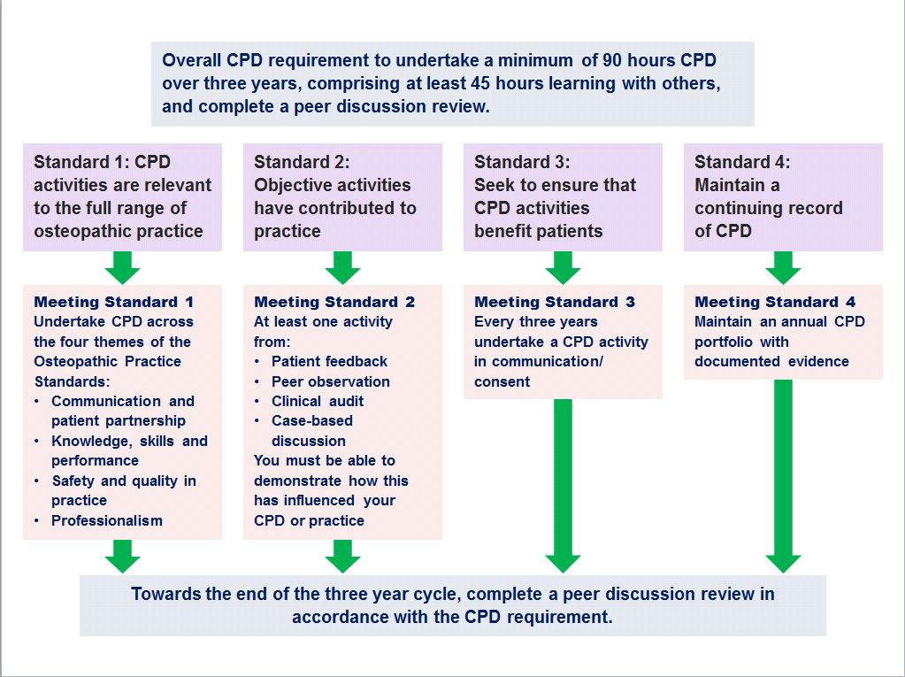
What is the CPD scheme?
The CPD scheme for osteopaths is illustrated in Figure 1 on page 3.
In order to provide assurance of continuing fitness to practise, the CPD scheme requires:
- A three-year CPD cycle of 90 hours of CPD, which is primarily self-directed. This must comprise a minimum of 45 hours of CPD ‘learning with others’ (This CPD should be undertaken at regular intervals throughout the CPD period so, for example, 30 hours of CPD, including 15 hours learning with others per year).
- Within the 90 hours, CPD must include a peer discussion review towards the end of the three-year cycle, which provides an opportunity to discuss practice and CPD and to confirm that all the scheme’s required elements have been completed and the CPD standards (see below) demonstrated. The required elements are:
- at least one objective activity that informs the overall CPD process – such as peer observation, patient feedback, clinical audit or case-based discussion
- at least one CPD activity in the areas of communication and consent
- CPD activities in each of the areas of the Osteopathic Practice Standards – communication and patient partnership; knowledge, skills and performance; safety and quality; and professionalism.
Compliance with the requirements of the CPD cycle, including peer discussion review, will mean an osteopath has demonstrated they have met the CPD standards and can move into the next three-year cycle. The CPD standards are outlined in Table 1 below along with an explanation of how the osteopath would show engagement.

The CPD standards outlined
Table 1
CPD standard description | CPD standard | What the osteopath must do across the three year CPD cycle
CPD standard 1 – Range of Practice | The osteopath demonstrates that CPD activities are relevant to the full range of practice. | Relevant CPD includes CPD activities in each of the areas of the Osteopathic Practice Standards related to individual professional practice  - communication and patient partnership  - knowledge, skills and performance  - safety and quality; and  - professionalism.
CPD standard 2 – Quality of care | The osteopath demonstrates that objective activities have contributed to practice and the quality of care | CPD includes at least one objective activity that informs the overall CPD process – such as peer observation, patient feedback, clinical audit or case-based discussion.
CPD standard 3 – Patients | The osteopath demonstrates that they have sought to ensure that CPD benefits patients (CPD in communication and consent) | CPD includes at least one CPD activity in the areas of communication and consent.
CPD standard 4 – Folder | The osteopath maintains a continuing record of CPD | The CPD folder should demonstrate that a three-year cycle of 90 hours of CPD, which is primarily self-directed, has been completed. This must comprise a minimum of 45 hours of CPD ‘learning with others’ (equivalent to an annual expectation of 30 hours of CPD, including 15 hours learning with others).
Sign off |  | Submission of a completed peer discussion review form to GOsC (on request).

Completing the CPD cycle
Osteopaths must select a peer (either an osteopath or other health professional) in order to undertake a peer discussion review towards the end of the CPD cycle. Many osteopaths will choose to identify their peer at the beginning of their CPD cycle and will discuss CPD and practice throughout the CPD cycle with their peer to bring full benefit to their professional development.
The peer discussion review, which must be completed and recorded on the peer discussion review form, before the end of the CPD cycle, provides an opportunity to discuss practice and CPD and confirm that all the scheme’s elements have been completed.
The completed peer discussion review form must be submitted to GOsC on request confirming completion of the CPD cycle. Further detail about the peer discussion review is outlined below.
What constitutes CPD?
Standard B3 of the Osteopathic Practice Standards (2018) states that osteopaths ‘must keep professional knowledge and skills up to date’. To achieve this, osteopaths must be professionally engaged, undertaking professional development activities and keeping up to date with factors relevant to ongoing practice (including the wider healthcare environment).
CPD is any activity that maintains, enhances and develops osteopathic professional practice. It includes any learning undertaken by an osteopath, for example discussion of CPD and practice with a colleague, courses, seminars, practical sessions, e-learning, reading, research, individual study, peer discussion review, mentoring and any other activities that can advance practice. Undertaking CPD is an ongoing aspect of professional practice.
CPD learning with others additionally must involve interaction (both giving and receiving information to inform learning) with osteopaths, healthcare practitioners or other professionals.
CPD must be reflected on and recorded by the osteopath within their CPD folder. The CPD microsite provides a range of examples and templates that can be used for this.
What is professional practice?
Professional practice can include clinical work (including safeguarding), education, research or management responsibilities. Over the course of a CPD cycle, CPD should be appropriately balanced across the whole of an individual’s practice. So, for example, an individual who only undertakes clinical work and holds no management or teaching responsibilities might confine all their CPD to clinical work. However, an osteopath who undertakes one day a week in education should undertake an appropriate portion of their CPD in the area of education or teaching practice, in addition to their CPD in clinical practice. Osteopaths with research or management responsibilities should be able to demonstrate balanced CPD in these areas.
The CPD process – submitting information to the GOsC
Start and end dates of the CPD cycle
The tables at www.osteopathy.org.uk describe the start and end dates of the new CPD cycles for all osteopaths with reference to their initial registration or renewal date.
Each year, as part of the registration renewal process, osteopaths will submit a self-declaration of the number of hours of CPD undertaken and any of the mandatory activities covered. An example declaration is outlined below.
Annual registration declaration
Each year, as part of their registration renewal, osteopaths will be required to submit the following information. The declaration below includes an illustrative example:
You are required, over 3 years, to undertake 90 hours CPD of which a minimum 45 hours must be learning with others. Over 3 years you will need to ensure you have undertaken activities across the four themes of the OPS, an objective activity, an activity focused on communication and consent and a peer discussion review towards the end of the three-year cycle.
Please declare how far you have progressed in completing these requirements by completing the declaration below.

30
In the past renewal year, I have undertaken hours of CPD

of which hours are in the category of learning with others.

15

I have identified my peer | Yes | No
I have undertaken activities which cover (please tick all that apply)
OPS Theme A |  | √
OPS Theme B
OPS Theme C |  | √
OPS Theme D
Objective activity |  | √
Communication and consent activity

I have completed and recorded my peer discussion review | Yes | No

An example CPD cycle
The example CPD cycle provided in Table 2 offers guidance on how the scheme could be undertaken and the feedback that the GOsC will provide throughout the cycle.
It is important that all osteopaths should aim to undertake the appropriate amount and balance of CPD in each year of the cycle.
All the requirements must be completed by the end of each CPD cycle in order to move into the next three year cycle.
The example in Table 2 illustrates how someone might choose to spread the mandatory activities across the whole of the three-year cycle, as part of their usual self-directed CPD. Some osteopaths may choose to undertake all their mandatory activities in year 1 and to continue undertaking self-directed activities in years 2 and 3. Osteopaths should take steps to ensure that they meet all the requirements by the end of year 3.
If it becomes apparent that exceptional circumstances will prevent an osteopath complying, the GOsC should be notified by the osteopath as soon as possible during the CPD cycle, along with documentary evidence and an application to vary the CPD requirement.
Example of how an osteopath might choose to spread the mandatory requirements across the three-year cycle
Table 2
Cycle 1 | Suggested CPD Hours | Example activities | Registration renewal
Year 1 | 30 hours of CPD (15 hours of learning with others) | Objective activity analysis and reflection plus other self-directed activities.  At this point, some osteopaths may also like to identify their intended peer who will complete the peer discussion review with them towards the end of the three-year cycle so that they can discuss informally their CPD plans and activities throughout the cycle. | At the conclusion of the first year, as part of the registration renewal, osteopaths will be asked to declare what they have undertaken within their CPD cycle as part of their registration renewal. This will comprise:  - the number of CPD hours completed  - the elements completed.  GOsC will aim to confirm that the osteopath is on track to complete the requirements of the CPD scheme by identifying what further CPD needs to be completed as part of the three year CPD cycle. Osteopaths can show this to their peer.
Year 2 | 30 hours of CPD  (15 hours learning with others) | CPD in consent and communication, plus other self-directed activities. | As above
Year 3 | 30 hours of CPD  (15 hours learning with others) | CPD completed in all themes of the OPS and across all aspects of professional practice plus self-directed activities.  Peer Discussion Review completed | The osteopath will submit a completed peer discussion review form, on request, to the GOsC which will confirm that the osteopath has completed:  - the CPD standards  - 90 hours of CPD (including 45 hours learning with others)  The osteopath will move into the next CPD cycle.  If all activities have not been completed, osteopaths will receive a warning that if they do not comply with the scheme within 28 days, they are at risk of being removed from the Register.
Peer Discussion Review
Towards the end of the CPD cycle (normally during year 3), all osteopaths must complete a peer discussion review in order to finish the current CPD cycle and move into their next CPD cycle.
A peer discussion review is a structured conversation with a peer who has been chosen by the individual osteopath; either a colleague or other health professional. There is a template to support this structured conversation in the associated Peer Discussion Review Guidelines.
It is important that osteopaths select and agree a peer with whom they are comfortable discussing their practice, areas of development and areas of strength so that the process supports enhancement of practice. Osteopaths may choose someone locally to be a peer, someone that they know, or may select someone through an educational institution, regional group or advanced practice society,
a member of the Osteopathic Alliance, or they may choose to ask the Institute of Osteopathy, other organisations or GOsC to help them to identify a peer to undertake their peer discussion review.
Many osteopaths will choose to select a peer at the beginning of the three year cycle and will discuss their CPD and learning throughout the CPD cycle, thus undertaking aspects of the peer discussion review at different stages throughout the three year cycle. Other osteopaths may prefer to have one structured formal conversation towards the end of the cycle.
During the peer discussion review structured conversation, the osteopath will discuss their osteopathic professional practice and their CPD activities to demonstrate that they have complied with the CPD scheme requirements and have therefore met the CPD standards. The peer discussion review itself should take around an hour to an hour-and-a-half to complete in total.
The peer discussion review provides the opportunity for a respectful and supportive
conversation about practice. Separate guidelines supporting the peer discussion review process are available.
The Peer Discussion Review Guidelines contain:
- information about how the peer discussion review works
- frequently asked questions
- a structured template to guide the discussion.
Completing the CPD Cycle
The CPD requirements are an important statement to patients and the public and other health professionals providing assurance that all osteopaths on the Register practise in accordance with published standards and requirements. All osteopaths must complete the CPD requirements by the end of their three year CPD cycle. Failure to comply with the CPD cycle means that the osteopath is at risk of their registration being removed unless there is good reason.
Osteopaths who are unable to complete the CPD requirement within the CPD cycle should contact the GOsC at the earliest opportunity to discuss this. There is a statutory process allowing the registrar to extend or vary the three year CPD requirement if there is good reason. Osteopaths wishing to make such an application must do so in writing providing supporting evidence.

GOsC verification and assurance activities
The GOsC will undertake activities to provide support to osteopaths and also to provide assurance that osteopaths are participating in the CPD scheme. These will include the following:
- GOsC will provide feedback to osteopaths, advising them whether or not they are on track for their three-year CPD cycle.
- GOsC will verify peer discussion review forms at the end of the CPD cycle to ensure that the Peer Discussion Review has been satisfactorily completed.
- A sample of CPD folders will also be checked to ensure that the documentary evidence of the 90 hours of CPD (including 45 hours of learning with others) has been recorded.
Quality assurance
Verification and assurance provides a level of quality assurance by checking compliance with the CPD scheme. Resources to support the quality of the peer discussion review process are also available, including support for conducting them. The templates to be completed as part of the peer discussion review process have been designed so that they support a structured conversation, enabling participants to ‘walk through’ the process, with the same questions being discussed, and the same guidance being applied, by all.
Organisations providing peer discussion reviews may put in place their own mechanisms of training and quality assurance.
Osteopaths will need to retain in their folders any documentation relating to incomplete peer discussion reviews.
Resources, templates and examples
Resources to help all osteopaths to complete the elements of the CPD scheme are available on the dedicated CPD microsite at cpd.osteopathy.org.uk
These resources include:
- instructions about how to complete an objective activity including patient feedback, Patient Recorded Outcome Measures (PROMs), clinical audit, case based discussion, peer observation
- blank templates to support osteopaths to complete activities, and reflect on and record activities
- completed examples by other osteopaths
- completed CPD folders
- completed peer discussion review forms
- contact details of groups that can help osteopaths complete CPD.

Osteopaths registering for the first time on or after 1 October 2018, in their first CPD cycle, will undertake the CPD requirements within 2 years and 10 months by completing a total of 85 hours of CPD including 42.5 hours of learning with others. These CPD cycles are defined in the CPD rules as ‘CPD periods’.
‘Learning with others’ means ‘any relevant learning activity that involves interaction (both giving and receiving information to inform learning) with osteopaths, healthcare practitioners or other professionals.’‘
The peer discussion review is required as part of CPD cycles commencing on or after 1 October 2018.

