Consultation: Continuing Professional Development and Peer Discussion Review Guidance
26 February 2018 to 14 May 2018
About osteopathy and osteopathic regulation
- The General Osteopathic Council (GOsC) regulates the practice of osteopathy in the United Kingdom. By law osteopaths must be registered with the GOsC in order to practise in the UK.
- Osteopathy is a primary healthcare profession, and is recognised as an allied health profession within the NHS see (www.england.nhs.uk).
- There are around 5,300 osteopaths registered with the GOsC who are able to practise osteopathy in the UK, with the register growing at a rate of approximately 2% a year. Osteopaths practise primarily in the independent sector but around 1 in 10 work in the National Health Service (NHS) or treat NHS-funded patients.
- All osteopaths are trained to be able to take a history, examine a patient, form a differential diagnosis and treat or refer. Osteopaths hold a variety of clinical roles in the private and public sectors: in independent clinics; within NHS general practice (GP); and in secondary and tertiary settings. Osteopaths often practise alongside a range of other health professionals, and may also be dually qualified as medical doctors, nurses, physiotherapists or in other disciplines.
- Osteopaths may also undertake a wide variety of roles including education, research, and management, which are also important aspects of osteopathic practice.
- There are around 800 osteopathic students in nine educational institutions in the UK. These include health faculties at universities, and other higher and further education institutions. All osteopaths must meet the requirements of the Osteopathic Practice Standards in order to be entered onto the Register, and must undertake mandatory continuing professional development (CPD). CPD is designed to enhance practice and patient safety, providing assurance of osteopaths’ continuing fitness to practise.
- The over-arching objective of the GOsC is the protection of the public. We also have statutory objectives to:
  - protect, promote and maintain the health, safety and wellbeing of the public
  - promote and maintain public confidence in the profession of osteopathy and
  - promote and maintain proper professional standards and conduct for members of that profession.”

- We do this through:
- setting standards and assuring the quality of undergraduate and
pre-registration osteopathic education and entry to the Register
- keeping a Register of all those permitted to practise osteopathy in the UK
- setting, maintaining and developing standards of osteopathic practice and conduct and ensuring that all osteopaths undertake continuing professional development (CPD)
- helping patients with any concerns or complaints about an osteopath and having the power to remove from the Register any osteopaths who are unfit to practise.
About this consultation
- Our new CPD scheme aims to better support osteopaths to maintain and enhance practice and we want osteopaths to participate successfully to achieve these goals.
- The scheme is outlined in the Continuing Professional Development Guidance (CPD Guidance) and the Peer Discussion Review Guidance (PDR Guidance) which aim to give osteopaths all the information that they need to successfully participate in the CPD scheme, gain reassurance and professional support, and continue to enhance their practice.
- The purpose of this consultation is to:
- seek feedback about the clarity of the continuing professional development guidance, which includes guidance about peer discussion review, ahead of the new CPD scheme coming into force from 1 October 2018, and
- identify further resources to help osteopaths participate in the CPD scheme successfully, achieving the anticipated benefits of the scheme, which include professional support, learning communities and enhanced patient care.
How to respond
- Respondents are invited to complete the consultation form and/or send in specific comments or suggested changes on the guidance. This feedback will help to inform the final versions of the CPD Guidance and PDR Guidance, and will also inform the guidance, ideas and resources on our dedicated CPD website at cpd.osteopathy.org.uk.
What is the new CPD scheme?
- The new CPD scheme is outlined in the diagram at figure 1.

Figure 1 – The new CPD Scheme
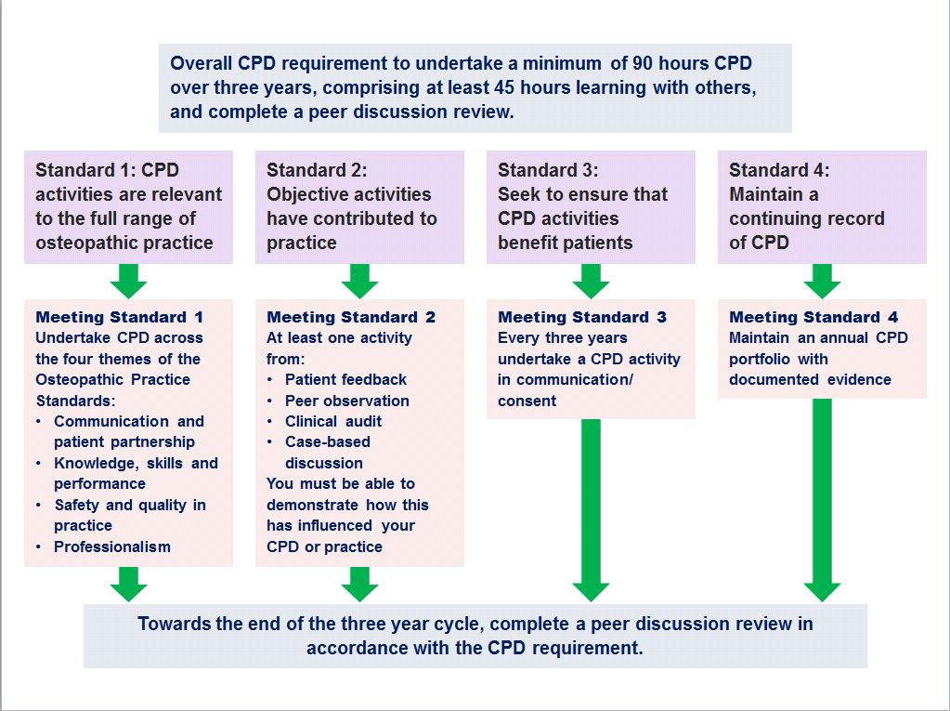
- The scheme aims to encourage osteopaths to discuss CPD and practice with others, reduce isolation, and enhance practice.
- The scheme was developed by osteopaths and patients to support and enhance patient care and osteopathic practice. It requires the same number of CPD hours as now, but features a more flexible three-year cycle, with ninety hours of CPD activity (including at least 45 hours of learning with others). Osteopaths will still choose CPD which is appropriate to their practice but will need to make sure that, within the three year period, they:
- include activities that relate to the four themes of the Osteopathic Practice Standards (communication and patient partnership; knowledge, skills and performance; safety and quality in practice; and professionalism),
- undertake an ‘objective’ activity. This is any activity where osteopaths get feedback on their practice. Osteopaths can choose an activity that is important to them and their practice (for example, patient feedback, discussion about a case, clinical audit, or feedback from another osteopath or health professional invited in to observe);
- refresh and update their knowledge and skills in communication and consent at least once during the CPD cycle;
- choose a peer or other health professional and have a discussion with them, so together they can look back and confirm completion of their CPD cycle before the end of the three year period.
- Guidance, ideas and resources to help osteopaths to complete these new features are available at: cpd.osteopathy.org.uk.

The CPD Guidance
- The CPD Guidance explains what osteopaths do to undertake the CPD scheme across the three year CPD cycle. The CPD Guidance emphasises the importance of the scheme contributing to an environment where osteopaths support each other to discuss CPD and practice, seek advice and consider new perspectives.
It comprises the following sections:
- Introduction and culture
- What is the CPD scheme?: a summary of the CPD scheme, the CPD standards and completing the completing the CPD cycle
- What constitutes CPD: the definition of CPD
- What is professional practice?: the definition of professional practice
- The CPD process: submitting information to the GOsC
- An example CPD cycle
- Peer discussion review
- Verification and assurance
- Quality assurance
- Resources, templates and examples: the CPD Guidance refers to the resources including blank templates and completed examples from other osteopaths, on the dedicated microsite at cpd.osteopathy.org.uk .
Peer discussion review guidance
- The PDR Guidance is designed to be a stand-alone document that explains what to do and how to do it, to help osteopaths and their peers complete the peer discussion review. This guidance also emphasises the importance of the scheme contributing to an environment where osteopaths support each other to discuss CPD and practice, seek advice and consider new perspectives. It comprises the following sections:
- Introduction and culture
- The CPD standards
- About the CPD scheme
- About the peer discussion review
- Frequently asked questions
- The peer discussion review template: this is a self-contained template that is completed as part of the peer discussion review.

Consultation questions:
- There are eight consultation questions, which are set out below. Information about how to respond to the consultation can be found in the next section headed, How to respond.
- Do you agree that the Continuing Professional Development (CPD) Guidelines are clear?
- How could the CPD Guidelines be improved?
- Do you agree that the Peer Discussion Review (PDR) Guidelines are clear?
- How could the PDR Guidelines be improved?
- Having read the guidance and reviewed the resources on our website at cpd.osteopathy.org.uk, what questions do you have about the CPD scheme?
- Do you think the guidance or resources outlined above would have a disproportionate effect upon any particular group?
- If yes, please explain what the effect would be and how you think it could be mitigated.
- Any other comments?
Consultation Questions
- Name of individual or organisation (optional)
- Are you happy for the GOsC to publish your response to this consultation?
Happy for GOsC to publish my response
I would prefer my response to be published in a non-attributable form
- Do you agree that the Continuing Professional Development (CPD) guidelines are clear?
Yes
No
- How could the CPD Guidelines be improved?
- Do you agree that the Peer Discussion Review (PDR) Guidelines are clear?
Yes
No
- How could the PDR Guidelines be improved?

- Having read the guidance and reviewed the resources on our website at cpd.osteopathy.org.uk, what further questions do you have about the CPD scheme?
- Do you think the guidance or resources outlined above would have a disproportionate effect upon any particular group?
Yes
No
- If yes, please explain what the effect would be and how you think it could be mitigated.
- Any other comments?
Thank you for your response to this consultation.
We would also like to ask some questions about you. Completing the diversity questionnaire is optional, but we would welcome information about our respondents. The information you provide will only be used for the purposes of analysing the consultation responses.

