Amendments to the General Osteopathic Council (Continuing Professional Development) Rules Order of Council 2006

Summary
- In line with the expectations set out in the Government Policy Paper Enabling Excellence, the General Osteopathic Council (GOsC) has been developing an evidence base for a proportionate approach to continuing fitness to practise, supported by academic research and engagement. Our new continuing professional development (CPD) scheme builds on the existing scheme and provides mechanisms to focus on high quality care for patients, further mitigating the impact of professional isolation, whilst also ensuring a proportionate approach to regulation with no additional burden because no additional CPD hours are expected.
- Osteopaths work mostly without teams and employers. They are trained to take a case history, perform an examination, make a diagnosis and agree a treatment plan (which may include referral to a GP for appropriate symptoms and conditions). Potential risks arise in diagnosis and treatment, from the clinical context of practice and the vulnerability of patients who dress down for examination and treatment. Effective communication and professionalism are vital for patients’ positive therapeutic experience.
- The GOsC has developed and consulted on changes to its existing CPD scheme extensively engaging with stakeholders including osteopaths and patients. This programme of work concluded in 2015 with a wide ranging consultation on the final details of the new scheme.
- In February 2016, following consideration of the consultation analysis and findings, the GOsC agreed the new CPD scheme.
- This consultation document sets out minor changes to the proposed, amended consolidated version of The General Osteopathic Council (Continuing Professional Development) Rules Order of Council 2006 (CPD Rules) in order to bring the scheme fully into effect.
Discussion
- The new GOsC CPD scheme is outlined in revised Continuing Professional Development Guidance and Peer Discussion Review Guidance.
- The key elements of the new CPD scheme are outlined in the figure below.
- The new CPD scheme is greatly simplified (with a lot of unnecessary detail about what ‘counts’ as CPD removed) and centres on a three year cycle and completion of a peer discussion review as part of the CPD requirement.
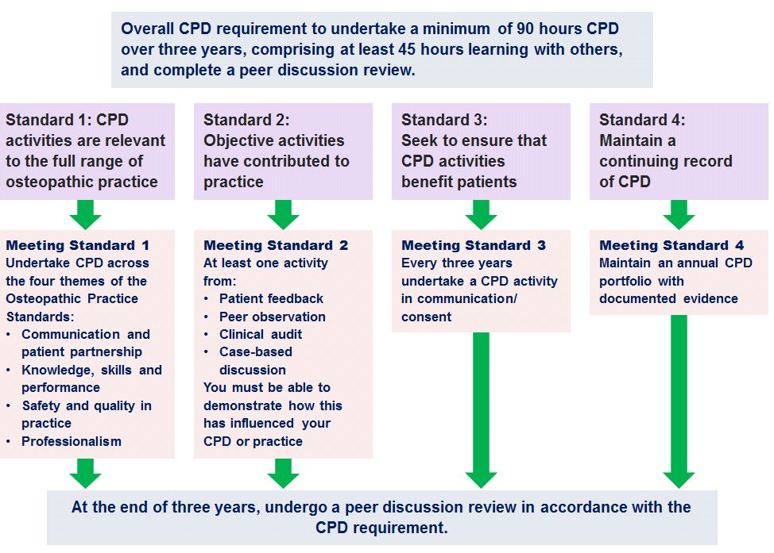
- The Peer Discussion Review is the central component of the scheme as it brings together features of the new scheme and consolidates impact on the osteopath’s practice through a discussion or dialogue with a peer (either an osteopath or other health professional) in order to provide assurance of practice in accordance with standards allowing the osteopath to complete one CPD cycle and to move in to the next.
- The Peer Discussion Review incorporates four simple standards outlined in the table below.
CPD standard description | CPD standard | What the osteopath must do
CPD Standard 1 – Range of Practice | The osteopath demonstrates that CPD activities are relevant to the full range of practice. | Relevant CPD includes CPD activities in each of the areas of the Osteopathic Practice Standards related to individual professional practice  - communication and patient partnership;  - knowledge, skills and performance;  - safety and quality;  - professionalism.

CPD Standard 2 – Quality of care | Demonstrate that objective activities have contributed to practice and the quality of care | CPD includes at least one objective activity that informs the overall CPD process – such as peer observation, patient feedback, clinical audit or case-based discussion
CPD Standard 3 – Patients | Demonstrate that the registrant has sought to ensure that CPD benefits patients | At least one CPD activity in the areas of communication and consent
CPD Standard 4 –Folder | Maintain a continuing record of CPD | The CPD folder should demonstrate that a three-year cycle of 90 hours of CPD, which is primarily self-directed, has been completed. This must comprise a minimum of 45 hours of CPD ‘learning with others’ (equivalent to an annual requirement of 30 hours of CPD, including 15 hours learning with others).
Sign off |  | A Peer Discussion Review towards the end of the three-year cycle, which provides an opportunity to discuss practice and CPD and to confirm that all the scheme’s required elements have been completed and CPD Standards have been achieved.  Compliance with the requirements of the three-year cycle will mean an osteopath has demonstrated the necessary CPD standards and can move into the next three-year cycle.
Required legislative change
- In order to fully introduce the CPD scheme, small changes are required to our current CPD rules.
- The existing CPD rules need minor amendments to incorporate the new features of the scheme through:
  - A move to a three-year CPD cycle (from an annual cycle) to enable the incorporation of the new requirement for peer discussion review.
  - Inclusion of rules in CPD guidance (including a requirement for consultation on such guidance) describing how the CPD requirement may be satisfied. Such guidance includes instructions about how to undertake the Peer Discussion Review.
  - Removal of an anomaly whereby new graduates have an initial exemption from CPD.
A move from the annual cycle of CPD to a three year cycle of CPD
- Currently, osteopaths are required to complete 30 hours of CPD annually with at least 15 hours of CPD as learning with others. This overall requirement of CPD will not change, but instead, will be a period of 90 hours, (with at least 45 hours of learning with others) over three years. This overall requirement will also include the new features of the CPD scheme as outlined above. (The new features of the CPD scheme are a part of the 90 hours, not an addition to it).This policy intention was supported as part of our CPD consultation in 2015.
- This longer CPD cycle remains in line with those of other regulators to date. Other regulators’ CPD cycles range from five years General Dental Council, three years, for example, the General Optical Council and those registered with the Nursing and Midwifery Council to annual cycles, for example, the General Pharmaceutical Council and the General Chiropractic Council.
- As part of our annual re-registration process, we will, as now, require osteopaths to declare the amount of CPD that has been undertaken during that year. We will expect that CPD is completed at regular intervals throughout this period in accordance with Standard B4 of the Osteopathic Practice Standards which states you must: ‘Keep your professional knowledge and skills up to date’. (For example, osteopaths should aim to complete around 30 hours of CPD per year, as now.) We will audit a proportion of self-declarations as we do now. We will provide feedback to osteopaths to confirm what they need to do to complete the new three year CPD cycle.
- However, what will be different is that currently, if osteopaths have not completed their annual CPD requirement they must either:
  - make a statutory application to the registrar of exceptional circumstances to reduce or carry over hours to the next CPD cycle or
  - be removed from the register for non-compliance.
- Under the new legislation, it will only be at the end of the three year cycle when osteopaths will be required to:
  - complete the CPD requirement
  - make a statutory application to the registrar of exceptional circumstances to reduce or carry over hours to the next CPD cycle or
  - be removed from the register for non-compliance.
Inclusion in rules of CPD guidance with a requirement to consult
- The current CPD Guidelines set out very detailed expectations of what is acceptable CPD providing detail about the current CPD requirements. These Guidelines are made under general powers to issue guidance contained in paragraph 15(1) to Schedule 1 of the Osteopaths Act 1993. However, these Guidelines are not currently referred to in the CPD rules.

- We suggest that CPD Guidance, indicating how to undertake the CPD requirements outlined in the CPD rules, should be referred to explicitly in the CPD rules, with requirements to consult on it, so that guidance indicating how to undertake the CPD requirement is explicit and clear to all. We regard this as good administrative practice (as it is both inclusive and transparent) which ensures that our stakeholders can participate in the evolution of requirements that will affect them. Indeed, imposition without consultation would bring a greater risk of non-compliance. Consultation requirements reflect our approach to inclusivity with our stakeholders.
- An alternative approach is to set out both the ‘what’ of the scheme and the ‘how’ to do the scheme in greater detail in rules. This would mean setting out specific CPD standards in the rules, defining timescales, mechanisms for selection of peers and content of CPD in legislation. The benefit of such an approach would be greater certainty. However, a significant disadvantage of such an approach would be the inability to change the rules in response to changing context or circumstances, societal or patient needs. We note that most other regulators do not have specific standards set out in rules in this way.
- The CPD Guidance and Peer Discussion Review Guidance documents were consulted on in 2015 and were supported. (See the consultation analysis outlined in paragraph 4). Since the consultation, the CPD Guidance has been updated to take into account feedback along with some specific development work on the peer discussion review guidance. The proposed CPD Guidance, incorporating the peer discussion review guidance show how the scheme will work and indicate how to complete each CPD cycle.
Removal of an initial exemption from CPD for new graduates
- Our current CPD rules provide that new graduates are exempted from CPD for their first CPD year if they register with us within three months of graduating. (See rule 5 of the current CPD rules). However, the transition into practice is a critically intensive learning period for osteopaths and a time when they should be encouraged to integrate within their professional community undertaking CPD. New graduates, patients and osteopaths have told us that this statutory exemption does not contribute to our policy intention of supporting new graduates as they make the transition into practice.
- The exemption was put in place at the outset of the CPD scheme because it was felt that it was helpful to allow newly graduated osteopaths time to establish themselves into practice. Osteopaths who were newly graduated were felt to be up to date. We are not aware of any similar exemptions existing in other regulators for new graduates.
- However, given the feedback from stakeholders that this is an anomaly in the legislation, we now feel that this should be removed. We therefore suggest that this anomaly in rule 5 should be removed.

Implementation timing
- We intend the three year cycle should be brought into force with effect from autumn 2018.
- From autumn 2018 onwards, there would in essence be a transitional period over the course of the year following introduction, when existing registrants would transfer from an annual cycle to a three year cycle. No peer discussion review would attach to this transitional period.
- Once they were on the three yearly cycle, registrants would still renew their registration annually, and would self declare their CPD each year. They would receive feedback which advised them each year what they needed to do to complete their three year cycle.
Equality Impact Assessment
- We have developed an equality impact assessment to assess any equality impact from the implementation of the proposals and this continues to be updated during the early implementation phase.
- The key areas identified by consultation respondents as potential concerns are all being addressed through our implementation work. For example:
- Registrants based overseas – In order to mitigate any impact, we have consolidated all guidance and resources online so that they can be accessed across the world (subject to local internet arrangements). We have run a series of early adopter seminars involving people in the UK and outside the UK which have enabled osteopaths outside of the UK to develop relationships with those inside the UK and in other countries. We have also undertaken engagement work with groups of osteopaths outside the UK, for example Gibraltar and the United Arab Emirates.
- Those who are not IT literate (potential suggestion of links to age) – We have a member of staff who is qualified in supporting people with a range of learning styles providing 1:1 support for osteopaths who need this. For example, 1:1 support has been provided to access webinars enabling osteopaths to join up with osteopaths in a way that suits them.
- Those with dyslexia, learning disabilities or visual disabilities – See above.
- Part time practitioners – Webinars have been provided at a range of times to enable people with caring responsibilities or outside commitments to access them at a time convenient to them
- Practitioners with ill health – As now, if osteopaths are unable to complete the requirements of the scheme due to ill health or other reasons, it is open to them to make an application to the registrar to reduce requirements or to carry them over to the next CPD cycle.
- The scheme is predicated on aspects of engagement, support and community and it is hoped that as the scheme rolls out and as our early adopter work rolls out, that we will create more inclusive communities of registrants in all of the categories identified above. Therefore it is hoped that the scheme will contribute to the promotion of equality.

